|  |  |
| --- | --- |
| About JZCP JZCP is a London listed fund that has investments in US and European micro-cap companies and US real estate. It receives investment advice from Jordan/Zalaznick Advisers, Inc. (“JZAI”), which works with the existing management of micro-cap companies to help build better businesses, create value and deliver strong returns to investors. | Investment Objective In August 2020, the Company's shareholders approved changes to the Company’s investment policy. Under the new policy, the Company will make no further investments except in respect of which it has existing obligations and to continue to selectively support the existing portfolio. The intention is to realise the maximum value of the Company's investments and, after repayment of all debt, to return capital to shareholders. |

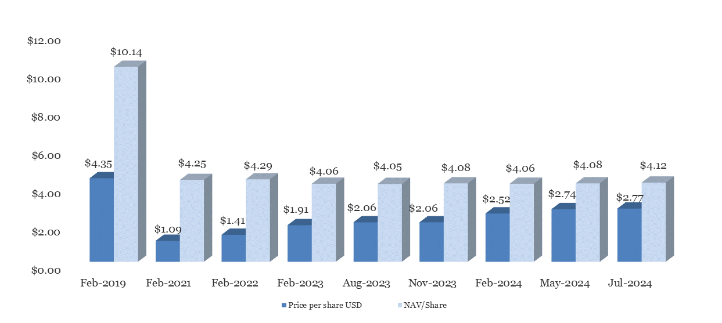



## 



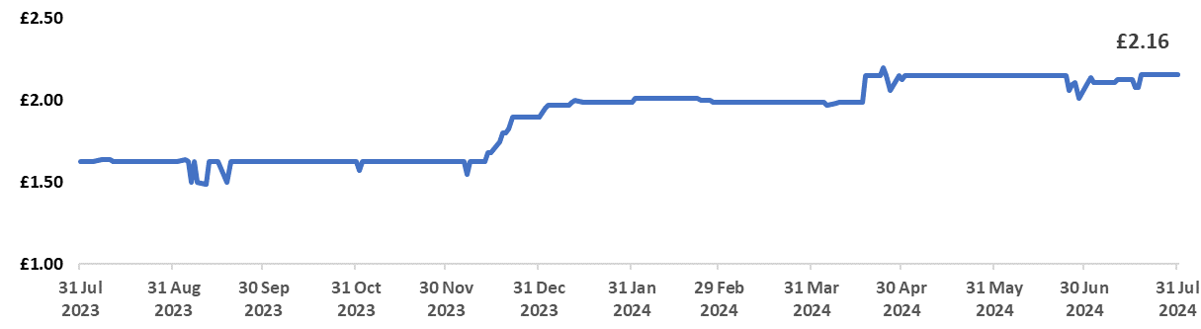

|  |  |  |  |
| --- | --- | --- | --- |
| Contacts | | | |
| Manager Jordan/Zalaznick Advisers, Inc. 70 E. 55th Street,  15th Floor  New York, NY 10022 | Auditor  Ernst & Young LLP PO Box 9 Royal Chambers St. Julian's Avenue  St. Peter Port Guernsey, GY1 4AF | Registrar Equiniti Limited Aspect House Spencer Road Lancing West Sussex, BN99 6ZX | Administrator Northern Trust International Fund  Administration Services (Guernsey)Limited  Trafalgar Court  Les Banques  St. Peter Port  Guernsey, GY1 3QL |
| If you want more information regarding JZCP, please call Kit Dunford at FTI Consulting on +44 (0)20 3727 1143. | | | |

Disclaimer

This Monthly Fact Sheet updates as of 31 July 2024 various information as to JZCP and its investment portfolio available from third parties as well as the valuations shown for unquoted Micro-Cap and Mezzanine investments. Before making investment decisions, investors should consider that the value of JZCP’s investments, and the income from them, may go down as well as up and is not guaranteed; that the market price for JZCP shares, depending on supply and demand, may trade at a discount to NAV; and that past performance cannot be relied upon as a guide to future performance. Investors should also consult with their own independent financial and tax advisers when making investment decisions. Although issued and approved by JZCP, this Monthly Fact Sheet does not constitute a solicitation or advice to buy or sell any security.